5. Git HandsOn

Please follow the instructions to complete the hands-on. Each instruction expects a command for the Git Bash.
- Verify if master is in clean state.
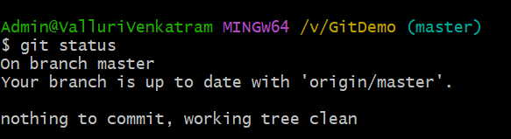
- List out all the available branches.
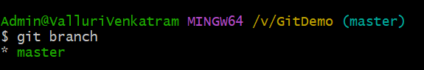
- Pull the remote git repository to the master
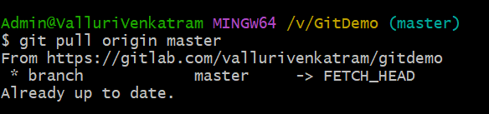

- Push the changes, which are pending from “Git-T03-HOL_002” to the remote repository.
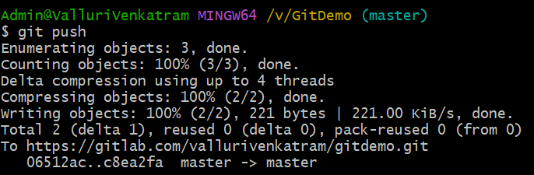
- Observe if the changes are reflected in the remote repository.
